Secure Coding Lab-2

Chekuri.mahesh

18BCN7101L39+L40

# Installing Software silently using CMD

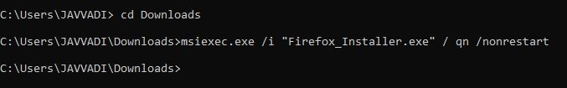

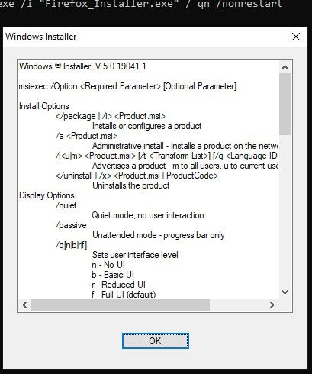

1. Whoami



It will show our user name. We can know in which user account we are currently operating.

# Net User

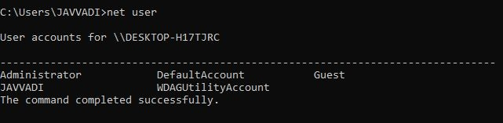

It lists out no of users present in our PC and their account type.

# Pushd and Popd

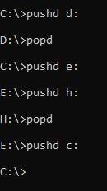

Here, i shift from one drive to another suing pushd command and come back to previous using popd

# Assoc

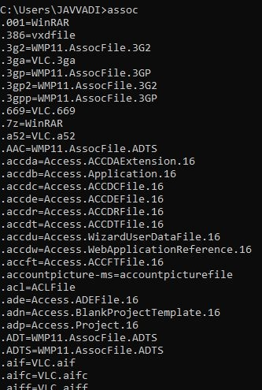

It will list out a lot of formats like these.

# Creating and deleting a Folder using CMD

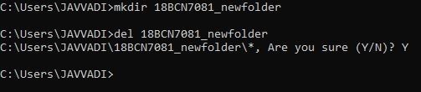

Here, I created a Folder and deleted it using cmd

# Time

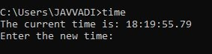

Here, using this command, we can see our current time and can change it.

# Tree